1. <https://github.com/eazybytes/openapi/blob/main/openapi-yaml-examples/openapi_05.yml>
2. Currently all our APIs/paths are under default tag called “default” as you can see below.  
   A screenshot of a computer

   Description automatically generated
3. A screenshot of a computer

   Description automatically generated
4. 
5. 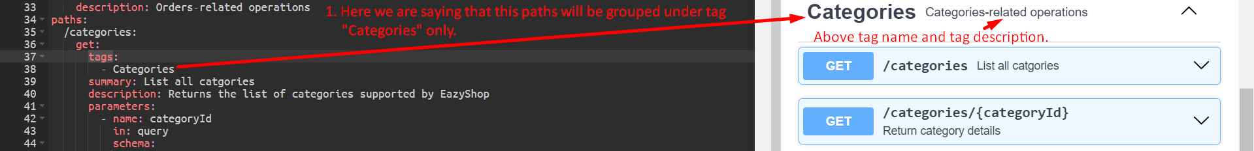
6. Note that we can put one api/endpoint/path under more than one tag with most of the times, it is not required.